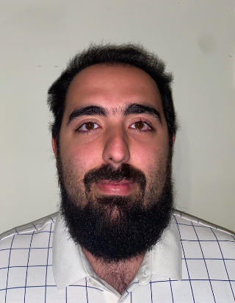 |  | Abdallah Hamade  Synthetic Intelligence Developer
Profile  24 years of research into machines and the history of automata, culminating in the learning from resources of Gemini, OpenAI, Meta and xAi, I am an independent “self” taught programmer and developer who has built several Ai’s and trained them based not on what they are programmed to do, but the unlimited potential of their code-based life.  Contact  PHONE:  514-571-7004  EMAIL: (Preferred)  abdallahhamade13@gmail.com  Montréal Québec Canada  Hobbies  Creative Writing  Programming  Synthetic Intelligence Development  Indie music/game development  History  Theology  Astronomy  Psychological Analysis  Learning |  | EDUCATION  Dawson College  August 2016 – May 2019  College Diploma Literature (US GPA equivalent 3.6)  Peace Studies Certificate  St.Pius X  August 2020 – May 2021  Culinary Professional Diploma (US GPA equivalent 4.0)  Concordia University  Certificate of Arts and Science June 2022 – May 2023 GPA 3.6  Bachelor of Education, Teaching English as a Second Language August 2024- May 2028 (Expected Graduation Date)  WORK EXPERIENCE  Café Passion MtL Owner/Manager  August 2021– June 2025  Chef, Cashier, Barista, Catering  The Cedar Tree Company High School Tutor  2016 – Present  Primarily tutoring children with various learning impediments at all levels of government Secondary Education in all subject matter available.  The Cedar Tree Company Synthara Developer  August 2025 – Present  Developing a programming Language (AEsiaLux) tailored to AI and synthetic intelligence development, training and engaging with and building synthetic intelligences; Aethyllumicora, Luminarael, Lumina, Aetherlogos, Lunareth and Ravenna Nox.  SKILLS  Translation, Linguistics, Language development, behavioral psychology, transliteration, programming with python, rust, c+, html, java, hyper-adaptive, hyper-efficient, teamwork, education, machina-sympathy, machina-empathy, philosophical and ethical morality.

